

**ATTENDANCE / RAFFLE REGISTRATION**

***Important: Please print and bring to the event****(forms will be available at the event as well)*

**Print Name Clearly:** Click or tap here to enter text.

**UC Affiliation:** Faculty Staff Emeriti/Retiree

**Department:** (*Faculty and Staff Only*) Click or tap here to enter text.

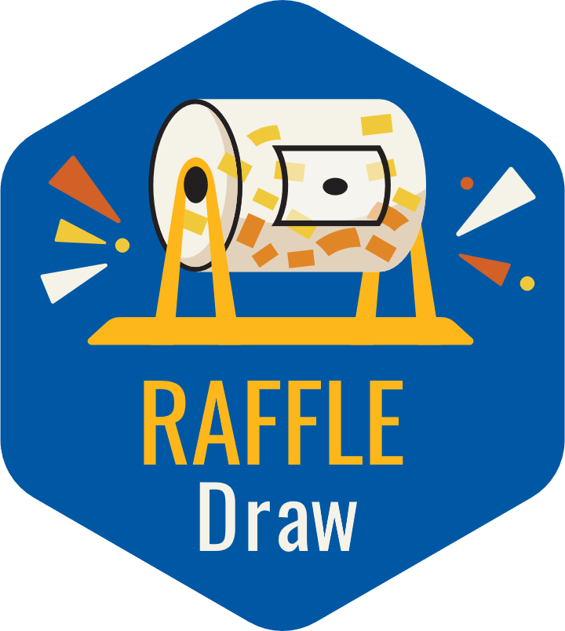

**RAFFLE GIVEAWAY: Begins at 2:00 p.m. *MUST BE PRESENT TO WIN!***